|  |
| --- |
| *This document was processed through automated translation with post-edition. In case of discrepancy with the original document, the source document prevails.* |

RSSH Gaps and Priorities Annex

**Date Published:** 31 July 2022

Instructions and illustrative examples to support applicants complete this template are available below.

**Section 1 – Analysis of RSSH priorities, including those related to community systems strengthening, based on programmatic gaps**

Identify the top three priorities for RSSH (by module) for each disease program and briefly explain how investing in these areas will help to address specific programmatic gaps for HIV, TB and malaria, while contributing to RSSH and pandemic preparedness.

|  |  |  |
| --- | --- | --- |
| Disease component (based on allocation letter) | Top three RSSH priorities (by module), including those related to community systems | Link with specific programmatic challenges and/or priorities to ensure quality |
| HIV | 1. Strengthening Strategic Information Management 2. Strengthening laboratory systems to improve access to viral load measurement and baby diagnostics 3. Community systems strengthening | DHIS2 does not allow for the disaggregation of information by age groups, which limits analysis particularly for the HIV program, which seeks to limit new infections among 15–34-year-olds. It should also be noted that the non-setting of Community modules deprives those responsible of a vision of the community contribution to the system, while the latter deliver a preventive, promotional and curative package. Finally, the lack of HIV data entry at the level of health units (DHIS2) needs to be addressed.  The program faces ongoing challenges related to sample transportation and systems for sending results for early infant diagnosis and viral load. Sample collection and transport management is still not optimal and needs to be reviewed, and needs to build on the mapping of existing GeneXpert machines.  There are no standards and guidelines on the operationalization of community activities. The completed Community Health NSP left out some key issues relating to the RECO package, their motivation, the progressive integration of all priority areas of health (IMCI package, HIV, TB and malaria). Furthermore, there is a difficulty in integrating specific peer education approaches (PLHIV and KP) into the RECO approach. Finally, there are major weaknesses in the organization and coordination of community-based organizations, which limit their action and the level of their contribution. |
| Tuberculosis | 1-Human resources for health and quality of care  2-Strengthening Community systems   1. 3. Laboratory Systems Strengthening | The program faces challenges in the implementation and quality of care for TB cases, due to shortages of health human resources and poor distribution of health personnel across the territory and provinces.    The fight against TB still faces a low reporting rate for new cases, despite great efforts and encouraging results. Community-based TB case finding is still insufficient due to the low capacity of community-based organizations, particularly those fighting TB, and the lack of integration into the primary health care system.  The program faces challenges related to TB diagnosis, including the integrated transport of samples for exploitation and the rendering of results. In the last year, it is planned to further increase the number of newly notified patients. New GeneXpert machines will be purchased as funding allows (placed in the PAAR of the HIV/TB grant), and mapping is required to better meet requirements. |
| Malaria | 1. Human Resources for Health 2. Procurement and inventory management 3. Health Information System | Malaria control faces significant challenges in staffing, distribution and qualification of health workers, including community health workers, in case management at the primary health care facility and community level (community care sites).  Challenges related to supply chain management, product quality monitoring and drug resistance monitoring (applicable to insecticide-treated nets, rapid diagnostic tests and artemisinin-based combination therapies) and last-mile kit assembly and distribution of artemisinin-based combination therapies and rapid diagnostic tests to community health workers  Need to improve and evolve malaria surveillance and data collection tools and processes to enable continuous quality improvement (CQI) and accurate surveillance. |

**Section 2 – Prioritization process**

Based on the analysis above: (1) Explain the approach used by the disease programs to collaboratively discuss and prioritize their health and community system bottlenecks; (2) Summarize why these RSSH areas have been prioritized between the three diseases for inclusion in the funding request; and (3) Explain how these priorities are aligned with those articulated in the national health sector plan and other key national policies and strategies.

|  |
| --- |
| The three programs carried out an analysis of the results achieved during the current cycle (NFM3) and the difficulties they encountered in implementing the activities. Following the expression of the priorities which the programs consider should be addressed by the HSS grant (table above), two discussions took place between the three programs and the representatives of the various Directorates in order to reflect together on the answers to be given. This analysis converges on certain bottlenecks already identified by the actors of the system because they limit the access of patients to quality health care:  **Strategic information**: The health information system still has many weaknesses that hamper the accuracy and completeness of data, and ultimately the correct understanding of the situation of the response to the three diseases and its impact. Some data are not yet available in DHIS2 (including HIV and TB patients), others are being integrated, such as community or private sector data. In Provincial Health Divisions like Kinshasa’s, only ¼ of health units are set up in the DHIS2, severely distorting analyzes of service use and epidemiological profile. Faced with this situation, the activities chosen in this grant continue the effort in collecting, reporting and analyzing data through monitoring meetings. The setting of additional data in the DHIS2 is also planned. It should be noted that there is the strengthening plan for the 2021-2025 NIS and a digitization of information strategy that covers the entire country and a plan to strengthen the NHIS developed following the 2020 evaluation. For the healthcare sector, this strategy covers several aspects: the solarization of all health facilities to allow a continuous power supply necessary for the operation of the servers, the IT equipment, the installation of the information management software, the creation of the unique identifier, then the computerized patient file. Discussions between the Global Fund and the National Agency for Clinical and Digital Engineering in the Health Sector (ANI NHA) began more than a year ago because the process is long and requires important prerequisites. In the meantime, the grant will create a patient registry (programs will decide whether it is HIV or TB tracker) to provide a reliable database of patients on treatment, which will be fed back into the system when digitalization occurs. Finally, the information currently available on the management of the three diseases in the private sector will be consolidated in DHIS2, thanks to the setting up and collaboration with the private health facilities. This should provide a significant insight into the proportion of patients in private care in disease programs, as today only malaria has entered into discussions with health facilities and is collecting data through the SANRU PR (NFM3).  **The system of stock management and supply of health products**: the programs are still concerned with numerous stock shortages, linked to weaknesses in quantification, the lack of synchronization in the reporting of drug needs and in orders that are not placed at the same rate. Weaknesses in drug quality assurance and the lack of last-mile kit assembly and distribution to community health workers were cited by the programs. Finally, the breakdown of screening inputs, particularly for the diagnosis of babies, is a phenomenon regularly reported by the NACP, the Provincial Health Division and citizen observatories. There is no longer a strategic plan for the pharmaceutical sector, and the PNAM (National Essential Drug Supply Program) plan expired in 2020. The PNAM team is currently working on the definition of the strategy, which will be included in the new PNDS, and from which the sector strategy will be extracted. The PIM pillar of the NFM3 funding application consisted of 3 interventions. In view of the major challenges facing the pharmaceutical sector and the absolute priority placed by the programs, it was decided to develop six priority interventions. With these investments, the PNAM will ensure proper quantification of needs, sound planning and procurement, and logistics for transportation, storage and distribution. It will also consolidate the efforts begun in the logistics field, with the creation of the Technical Logistics Management Units, positioned in each Provincial Health Division, which are the result of the efforts made to date to monitor the supply chain.  **Human resources for health**: The programs highlighted one of the most well-known problems of the health system, namely the instability of existing staff. In the absence of a provincial civil service, as provided for by the Law on Decentralization, and in the Congolese context, where many professionals are appointed by the political actors (Governor, provincial minister), the staff of the Ministry of Health is out of control. The evaluation of the National Health Development Plan recalls that the distribution of staff reported by the DRHS for the year 2022 gives a total of 256,409 persons, including 154,235 (60%) health professionals and 102,174 (40%) administrative and support staff. For health professionals, nurses are the most numerous with 46%, followed by doctors with 7%. The deficiency is most pronounced in other, more prominent categories, such as pharmacy assistants, radiology technicians, sanitation technicians, physical therapists, midwives, and pharmacists. The distribution of the workforce shows a concentration in urban areas to the detriment of rural areas. In the provinces, we are even seeing the proliferation of a dual-residence phenomenon where health professionals have a residence in urban areas while working in rural areas where they go intermittently. Figures for the total number of staff by province indicate that Kinshasa has the largest number with 19%, followed by Kwilu (8%) and North Kivu (7%). The most deprived provinces are Bas Uele and Tanganyika, among others. As part of this, the grant includes the installation of human resources management software to obtain a consolidated view of all HRH in the targeted provinces, as well as the conduct of the technical streamlining process to determine the number of personnel required. Training will be given (particularly in primary health care management), but it is expected that the turnover of HRH will have an impact on all training. Similarly, the training of RECOS is provided for in the grant, in complementarity with the sickness programs, in order to ensure a good knowledge of the minimum integrated package.  **Community systems**: the three programs agree that community actors are an indispensable link in mobilizing, preventing, stimulating demand for health care and seeking care, but also in screening and community care. However, they regret a weakness in the structuring and organization of community systems, which still operate in a very fragmented manner, without clear standards from the Ministry of Health. The effort to effectively implement the integrated package will continue, as today community promoters are raising awareness about malaria and TB. The new National Strategic Plan is currently being drawn up and will serve as the basis for the reform, which is intended to enable the work of the Community players to be decompartmentalized in a sustainable way so that the RECOS implement an integrated package and their funding is channeled through a multi-donor fund. In addition, and with the same idea that community actors will be more effective and heard if they come together, the grant foresees that all the evidence gathered through community-led monitoring mechanisms will be analyzed, compiled into reports and used as a basis for broad advocacy on access to quality care for patients, including the 3 diseases. Finally, in response to the concern expressed by the disease programs, which regret the institutional weakness of CSOs, training and institutional strengthening are planned, after having carried out a mapping of the organizations involved in the prevention and management of the three diseases.  Several dimensions have also been taken into account in order to provide the most direct response possible to the problems raised by the three programs:  **The development of the new National Health Development Plan is not yet complete**, and the evaluation of the 2019-2022 re-framed National Health Development Plan struggles to give a reliable picture of progress due to a lack of sufficiently reliable and disaggregated data. In addition, many other directorates do not have an up-to-date strategic plan, such as the Pharmacy and Drug Directorate, the Community Health Sub-Directorate, the Health Human Resources Directorate, the Studies and Planning Directorate, in the process of being validated for the NSP SNIS. All of these documents are usually the strategic framework for HSS grants, but in their absence, the 2020 prioritization work has been taken up and updated, with the help of the sickness programs.  **The country's approach to submitting funding applications is based on renewal**, which implies some continuity in the interventions selected in 2020, with marginal changes. By 2020, pillars such as PIM or HRH had received little funding, while NHIS and integrated supervision had been favored.  Given the size of the country and the needs of its health system, as well as the presence of multiple partners (the map of TFPs is attached), **choices have been made to streamline investments, avoid duplication, and maximize the chances of results** for a more direct impact on malaria patients living with HIV and/or TB.  As a result of these discussions, the modules and interventions selected followed recommendations and priorities, placing the most important investments on the pillars mentioned above: NHIS, PIM, HRH and the strengthening of community systems. |

**Section 3 – Funding gap analysis**

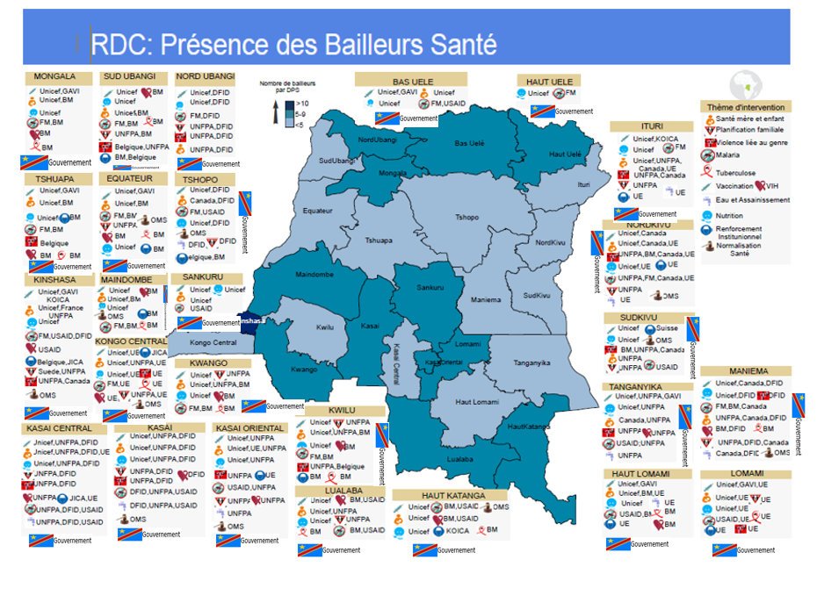

|  |  |  |
| --- | --- | --- |
| Module | Interventions | Funding gap analysis |
| Governance and planning | Health sector planning and governance for integrated people-centered services | A. Total amount required: data not available  B. Total amount funded and by whom: US$15 million funded by EU, more than US$ 5 million by domestic financing  C. Gap (A-B): US$10 million  D. Global Fund investment: US$504.441  E. Remaining gap (C-D): data not available |
| Health Financing | Health Sector Financing Strategy and Planning | A. Total amount needed: US$8.588 billion (based on UHC roadmap)  B. Total amount funded and by whom: US$ 846,723,434 financed by the Congolese Government from national funding  C. Gap (A-B): US$7,741,276,565  D. Global Fund investment: 470,832 US$  E. Remaining gap (C-D): 7,740,805,733 US$ |
| Community systems | Research and advocacy, CSO institutional strengthening, coordination, community-led monitoring | A. Total amount needed: US$142,755,138 (based on the assessment of the community-based NSP completed in December 2022)  B. Total amount funded and by whom: US$142,755,138 from USAID, World Bank, Global Fund, Unicef (via Gavi)  C. Gap (A-B): US$0 million  D. Global Fund investment for the following cycle: US$12 million  E. Remaining gap (C-D): US$130,755,138 |
| HPM systems strengthening | Quantification, improvement of supply chain information systems, improvement of storage and distribution capacity, design and operation, Policy, strategy and governance, expansion of the national supply chain system through outsourcing | A. Total amount required: no estimate available to date, the National Health Development Plan is in preparation and there is no updated strategy for either the HPMT or the National Access to Medicines Program  B. Total amount funded and by whom: US$ million (infra) financed by the World Bank and US$5 million (infra) financed by the Japan International Cooperation Agency, plus US$5 million from domestic financing, including a public-private partnership for greater coverage of manufacturers  C. Gap (A-B): US$XXX million  D. Global Fund investment: US$5,227,266 million for GC7  E. Remaining gap (C-D): US$XXX million |
| Human Resources for Health Quality of Care | Motivation, HRH Planning, Management and Governance, Continuing Education, Education and Production of New Health Workers, Integrated Supervision | A. Total amount needed: US$1,945,501,134  B. Total amount funded and by whom: US$1,945,501,134 (below) funded  C. Gap (A-B): US$0 million  D. Global Fund investment: 19 million US dollars for GC7  E. Remaining gap (C-D): US$0 million |
| Evaluation monitoring system | Data analysis, evaluation, review and use  Data Quality  Routine data reporting | A. Total amount needed: US$115,412,286  B. Total amount funded and by whom: US$115,412,286 (infra) funded by the Global Fund, , USAID, GAVI, JICA, UE  C. Gap (A-B): US$0 million  D. Global Fund investment: 6.084.274 million US dollars for GC7  E. Remaining gap (C-D): US$0 million |
| Laboratory Systems | Network optimization and geospatial analysis, national laboratory management and governance structures, quality management systems and accreditation, sample shipping and transportation systems, laboratory information systems | A. Total amount needed: US$51,395,800 based on the evaluation of the NSP laboratory  B. Total amount funded and by whom: US$25,800,000 (infra) financed by the Global Fund, World Bank, Expertise France  C. Gap (A-B): US$25,595,800  D. Global Fund investment: 6,084.274 million US dollars for GC7  E. Remaining gap (C-D): US$19.715.726 million |